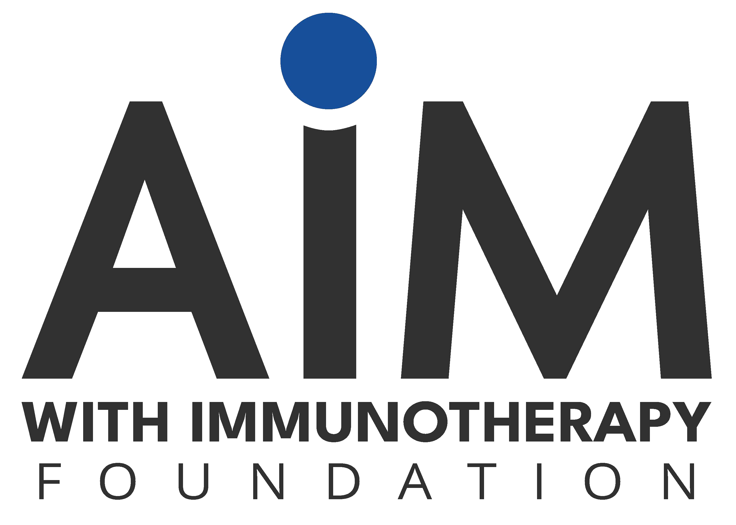

**Zenocutuzumab-zbco**

An HCP Tool from AIM with Immunotherapy

Zenocutuzumab-zbco (Bizengri) is a first-in-class, humanized, bispecific IgG1 antibody directed against two targets: HER-2 and HER-3. It is indicated for use in adults with advanced, unresectable or metastatic non-small cell lung cancer or pancreatic adenocarcinoma, both cancer indications harboring neuregulin 1 (*NRG1*) gene fusion with disease progression on or after prior systemic therapy.

### Clinical trial results for zenocutuzumab-zbco

In a tumor-agnostic, registrational phase 2 eNRGy clinical study, patients with advanced NRG1+ cancer received the drug.

* The response rate was 30%, with 47 out of 158 patients having a confirmed objective response
* The median duration of response among those patients was 11.1 months. Patients with NSCLC had a median of 12.7 months, with a range between 1.8 to 29.5 months. Patients with pancreatic cancer had a median of 7.4 months, with a range between 2.1 to 20.7 months.

### 

### Molecular biology and pharmacology for zenocutuzumab-zbco

The drug binds to the extracellular domains of the receptors, HER-2 and HER-3. The HER-2 receptor lacks a ligand, but will dimerize with members of the HER family, activating the receptors. Resulting signals will facilitate cell growth and proliferation. Through the inhibitory binding to HER-2 and HER-3, dimerization is inhibited.

When the antibody, zenocutuzumab-zbco, binds to HER-3, it also prevents binding of the EGF-like, glycoprotein, *NRG1,* to HER-3. Therefore, zenocutuzumab-zbco inhibits signaling through PI3K-AKT and mTOR pathways by interfering with *NRG1* binding to HER-3 and activation of the receptor.

An *NRG1* fusion protein occurs with the aberrant expression of the 3’ end of*NRG1*, which includes the EGF-like domain. Although it occurs in less than 1% of all cancers, chromosomal rearrangements involving *NRG1* can drive certain cancers, including NSCLC and pancreatic. The result of the *NRG1* gene fusion causes a protein that is constitutively active. This allows NRG1 to be a ligand for HER-3 itself and also facilitate the binding of HER-2 to HER-3.

Note: The indications for zenocutuzumab-zbco are approved under accelerated approval based on overall

response rate and duration of response. For the continued approval, it requires verification and proof of clinical benefit in confirmatory trials.

# DRUG DOSAGE AND ADMINISTRATION

Zenocutuzumab-zbco is an intravenous infusion, administered after dilution, over a 4-hour period. The recommended dosage of zenocutuzumab-zbco is 750 mg every 2 weeks until disease progression or unacceptable toxicity.

There is no dose modification recommended for zenocutuzumab-zbco. Adverse reactions that are categorized as mild necessitate the interruption of the infusion, treating the patient, and resuming at a lower rate (specifics indicated in the next section). In contrast, there are more serious scenarios that necessitate permanent discontinuation.

### Patient Selection

Patients eligible for this therapeutic must have an *NRG1* gene fusion. Currently, an FDA-approved, companion test for positive identification of *NRG1* gene fusions is unavailable (March 2025).

### Pre-treatment

Patients should have their left ventricular ejection fraction (LVEF) evaluated by a professional prior to receiving this medication.

### Pre-medications

To reduce the risk of infusion-related reactions, patients should receive the pre-medications indicated below prior to infusion, either administered orally or intravenously.

* Antipyretic – acetaminophen 1,000 mg
* Corticosteroid – dexamethasone 10 mg
* H1 anti-histamine – dexchloropheniramine 5 mg or the equivalent

### Infusion-Related Reactions

Reactions are possible during infusion. If there is a suspected infusion-related reactions/hypersensitivity/anaphylactic reactions, interrupt the infusion and monitor the patient until the symptoms resolve. Provide symptomatic treatment. Signs of this type of reaction include chills, nausea, fever, and cough. In clinical trials, 13% of patients experienced an infusion reaction of Grade 1 or 2 during their first infusion. The median time to onset was 63 minutes (ranging between 13 to 240 min).

* Grades 1, 2, or 3 – prepare to interrupt the infusion in these patients and administer symptomatic treatment. The rate of infusion can be resumed at a reduced rate (50% of the rate at which the reaction occurred) after the symptoms have resolved.
* Grade 4 – immediately stop the infusion and permanently discontinue the drug.

# SIDE EFFECTS AND MANAGEMENT

When administering zenocutuzumab-zbco, the **most common adverse reactions (≥ 10%) in patients** were abdominal pain, constipation, diarrhea, dyspnea, edema, fatigue, infusion-related reactions (IRR), musculoskeletal pain, nausea, rash, and vomiting. Among those, diarrhea (25-36% of patients experienced this effect) and musculoskeletal pain (23-28% of patients experienced this effect) were most common.

For **lab abnormalities, the most common Grade 3 or 4 (≥ 2%) were** decreased hemoglobin, decreased magnesium, decreased platelets, decreased phosphate, decreased sodium, increased AST, increased ALT, increased alkaline phosphatase, increased aPTT, increased bilirubin, and increased GGT.

### Black Boxed Warning

There is a warning for embryo-fetal toxicity with zenocutuzumab-zbco. Although there are no studies on the use of the drug in pregnant women, based on the mechanism of action, exposure to this drug during pregnancy is likely to cause harm to the embryo. Patients are advised to use effective contraception while being prescribed this drug. Animal studies did demonstrate that deficiencies in HER-2 and HER-3 (the targets of zenocutuzumab-zbco) causes malformation of the embryo and effects the cardiac system, vascular development and neuronal development. The IgG1 is also known to cross the placenta, allowing drug transmission to the developing fetus and embryolethality.

### Warnings and Precautions

There are three warnings associated with zenocutuzumab-zbco. These are for infusion-related reactions/ hypersensitivity/anaplylactic reactions, interstitial lung disease/pneumonitis, and left ventricular dysfunction.

### Infusion-Related Reactions

Due to the risk for infusion-related reactions/hypersensitivity/anaphylactic reactions, the drug should only be administered in a clinical setting equipped with emergency resuscitation equipment and trained staff. The clinicians need to monitor for infusion-related reactions and be prepared to administer emergency medication. The infusion may need to be interrupted, then reduced, or even stopped, depending on the severity of the reaction.

### Interstitial Lung Disease

Patients should be monitored for symptoms that may indicate interstitial lung disease/pneumonitis. The drug should be permanently discontinued with ≥ Grade 2 interstitial lung disease/pneumonitis. In clinical trials, less than 1.5% of patients experienced this effect.

* Grade 1 – interrupt the drug until the patient recovers. Initiate corticosteroids. Resume treatment after resolution.
* Grade 2 – permanently discontinue. Administer corticosteroids.

*Continued on the next page*

### Left Ventricular Dysfunction

Patients should have their left ventricular ejection fraction (LVEF) evaluated by a professional prior to receiving this medication. At regular intervals and during treatment, staff should assess LVEF. The drug should be permanently discontinued in those with symptomatic congestive heart failure.

If LVEF is 45-49% and absolute decrease from baseline ≥10% or LVEF <45%:

* Interrupt zenocutuzumab-zbco. Repeat the assessment of the LVEF within 3 weeks.
* If the LVEF is <45% or the LVEF has not recovered to within 10% from the baseline – permanently discontinue.
* If LVEF is 50% or greater or LVEF is 45-49% and recovered to within 10% of baseline, resume the medication and then monitor the LVEF every 12 weeks.

If the patient is symptomatic for congestive heart failure – permanently discontinue the drug.

### Other Reactions

Treatment with zenocutuzumab-zbco may cause other clinical issues.

* Grade 3 or 4 – Withhold the drug until the patient recovers to ≤ Grade 1 or baseline.

### OTHER TAKEAWAYS ABOUT ADMINISTRATION

* Embryo-fetal toxicity is possible due to the mechanism of action.
* Educate patients and caregivers about side effects and the importance of reporting symptoms as soon as possible.

# QUESTIONS & ANSWERS

|  |  |
| --- | --- |
| **Q.** | **How long can patients receive zenocutuzumab-zbco?** |
| **A.** | The drug is indicated until disease progression or unacceptable toxicity. In clinical trials with patients diagnosed with NSCLC, 17% of the patients received therapy for more than one year. For patients with pancreatic cancer, 13% were on zenocutuzumab-zbco for more than one year. Approximately half of all the patients in the clinical trial received the drug for at least 6 months. |
| **Q.** | **How often is the drug discontinued due to an adverse reaction?** |
| **A.** | Interruptions due to an adverse drug reaction occurred in 29% of patients diagnosed with NSCLC in clinical trials. For patients with pancreatic cancer, 33% experienced a temporary dose interruption of zenocutuzumab-zbco. The drug was discontinued in approximately 2-3% of patients overall. The reasons included for dyspnea, pneumonitis and sepsis. |
| **Q.** | **What is the most important thing for patients to know about zenocutuzumab-zbco?** |
| **A.** | The drug may cause infusion-related and allergic reactions. These may be life-threatening, although for the majority of patients, clinicians can manage the reaction. However, precautions are preemptively taken with zenocutuzumab-zbco. Prior to infusion, premeditations should be given to reduce the chance for an infusion-related reaction to occur, especially with the first infusion. In addition, the patient should be monitored for symptoms for at least 1 hour after their first infusion. |
| **Q.** | **How do you modify the dose of zenocutuzumab-zbco for an adverse event?** |
| **A.** | There is no dose reduction or modification recommended for zenocutuzumab-zbco. Depending on the type of reaction that occurs, the infusion might be interrupted or discontinued. |

**PATIENT RESOURCES**

## ADDITIONAL INFORMATION RESOURCES

**American Cancer Society**

Patient programs, services, 24/7 hotline, etc

https://www.cancer.org/

**National Cancer Institute**

Information about cancer types, treatment, side effects, find a clinical trial, etc

https://www.cancer.gov/

## FINANCIAL ASSISTANCE

#### Cancer Financial Aid Coalition

Facilitates communication, educates and advocates for patients. [www.cancerfac.org](http://www.cancerfac.org/)

#### Centers for Medicare and Medicaid Services (CMS)

Apply to determine if you are eligible for government assistance. [www.cms.gov](http://www.cms.gov/) or [www.medicare.gov](http://www.medicare.gov/)

800-633-4227

#### Lazarex Foundation

Provides assistance with travel costs for clinical trial participation. Ask your social work counselor for a referral if you have been consented to a clinical trial for melanoma.

[www.lazarex.org](http://www.lazarex.org/)

#### Needymeds

Database to search for free or low-cost medications, help with medical transportation and other resources. [www.needymeds.org](http://www.needymeds.org/)

#### Patient Advocate Foundation

Provides assistance with mediation, financial stability, and other assistance. Funds subject to availability. Patient must meet their eligibility for financial assistance.

[www.patientadvocate.org](http://www.patientadvocate.org/) 800-532-5274

**The Sam Fund for Young Adult Survivors of Cancer**

Assists cancer survivors ages 21-39 with their transition into post-treatment life. This program distributes grants and scholarships in an effort to enable survivors to pursue goals.

[www.thesamfund.org](http://www.thesamfund.org/) [info@thesamfund.org](mailto:info@thesamfund.org)

## PRESCRIPTION ASSISTANCE

#### CancerCare Co-Payment Assistance Foundation

Helps with the cost of medication. Availability of funds for patients with specific cancers is subject to availability. [www.cancercarecopay.org](http://www.cancercarecopay.org/)

1-866-552-6729

#### Medicine Assistance Tool

Database to search for patient assistance resources offered by pharmaceutical companies. [www.medicineassistancetool.org/](http://www.medicineassistancetool.org/)

#### Patient Advocate Foundation Co-Pay Relief

Provides direct financial support to patients who medically qualify. Funds subject to availability.

<https://copays.org>

1-866-512-3861

#### Good Days

Provides assistance with insurance co-pays, and prescription medications. Funds subject to availability.

[www.mygooddays.org](http://www.mygooddays.org)

#### Health Well Foundation

For patients who cannot afford insurance premiums, co-payments, co-insurance, or other out-of-pocket health care costs. Funds for patients subject to availability. Patient must also meet eligibility for financial assistance.

[www.healthwellfoundation.org](http://www.healthwellfoundation.org/) or [grants@healthwellfoundation.org](mailto:grants@healthwellfoundation.org) 1-800-675-8416

#### The Assistance Fund, Inc

Provides prescription copay and financial assistance, including health insurance premiums. Funds subject to availability.

[www.theassistancefund.org](http://www.theassistancefund.org/)

<https://tafcares.org>

1-855-845-3663

#### PAN Foundation

Provides financial assistance to cover out-of-pocket treatment costs. Funds subject to availability.

[www.panfoundation.org](http://www.panfoundation.org/) 1-866-316-PANF (7263)

#### Patient Assistance Program

Comprehensive database of patient assistance programs offering free medications. [www.rxassist.org](http://www.rxassist.org/)

[info@rxassist.org](mailto:info@rxassist.org)

## HOUSING

#### American Cancer Society – Hope Lodge

Provides free housing during treatment appointments. Requires a referral from your social worker. [www.cancer.org/](http://www.cancer.org/)

1-800-227-6333.

**American Cancer Society – Extended Stay America**

Partnership to offer discounted rooms for patients who have to be away from home for cancer treatment.

https://www.cancer.org/about-us/our-partners/extended-stay-america.html

1-800-227-2345

**Healthcare Hospitality Network**

Connects patients and their caregivers looking for lodging near their healthcare provider

https://members.hhnetwork.org/locate-a-house

1-800-318-8861

**Joe’s House**

Helping patients with cancer find lodging throughout the U.S.

https://www.joeshouse.org/lodging?state=0

1-877-563-7468

**National Council of State Housing Agencies**

Emergency rental assistance programs available by state. Federal grants still available in some areas.

https://www.ncsha.org/emergency-housing-assistance/

## TRANSPORTATION (AIR AND GROUND)

**Air Charity Network**

Provides access for people in need who are seeking free air transportation to specialized health care facilities

http://aircharitynetwork.org/

1-877-621-7177

**Corporate Angel Network**

Nonprofit organization that helps cancer patients by arranging free travel on corporate aircraft

https://www.corpangelnetwork.org/

info@corpangelnetwork.org

1-914-328-1313

#### Medicaid

Ground transportation only. Sets up rides and provides mileage reimbursement for Medicaid patients only. 1-877-633-8747

#### Mercy Medical Angels

Provides free medical transportation (flights, gas cards, bus and train tickets) for patients with financial needs who need to travel more than 50 miles. Patients must meet their eligibility for financial assistance. [www.mercymedical.org/](http://www.mercymedical.org/)

#### Pilots for Patients

Provides free flights to people in need of medical treatment. Patient must be medically stable to fly and be ambulatory. Ask your social worker about a referral.

[www.pilotsforpatients.org](http://www.pilotsforpatients.org/) 318-322-5112



# ADDITIONAL RESOURCES

Bizengri (zenocutuzumab-zbco) injection [prescribing information]. Partner Therapeutics, Inc. Lexington, MA 02421. Available at: https://bizengri.com/pdf/BIZENGRI_Full_Prescribing_Information_2025.pdf. Accessed 4.28. 2025. Revised 3.2025.

Laskin J, Liu SV, Tolba K et al. *NRG1* fusion-driven tumors: biology, detection and the therapeutic role of afatinib and other ErbB-targeting agents. *Ann Oncol*. 2020;31(12):1693–1703. doi: 10.1016/j.annonc.2020.08.2335

Schram AM, Goto K, Kim DW et al. Efficacy of Zenocutuzumab in *NRG1* Fusion-Positive Cancer. *N Engl J Med*. 2025;392(6):566–576. doi: 10.1056/NEJMoa2405008